Beta project
Group 18 – Arvid Johansson, Ludvig Wintoft, Otto Björckebaum, Edson Nagabona Kuzengwa
AI2135 Financial Investment 2025

Introduction
The purpose of this project is to estimate and interpret different risk measures calculated with the Capital Asset Pricing Model (CAPM) and the Fama-French Three-Factor Model. CAPM will be used to estimate beta, alpha and R-squared for five Swedish stocks and Fama-French will be used for five U.S stock. Utilizing weekly return data from 2018 to 2025 together with the SIX return index this report will regress data from five companies at the Stockholm Stock Exchange. Additionally, this report will use stock returns from three U.S companies during 2014 to 2025 and applying the Fama- French Model to compare with CAPM.

Data and Methodology
The following formulas will be used.
CAPM:
$${(R}_{i}- R_{f})=α_{i}+β_{M}\left(R_{m}-R_{f}\right)+ε_{i}$$
CAPM is an model to determine the required rate of return of an investment dependent on risk free rate ($R_{f}$), Beta (β), alpha ($α_{i})$ and market risk premium ($R_{m}-R_{f})$. Where beta measures systematic risk and alpha indicate mispricing.
Fama-French model:
$${(R}_{i}- R_{f})=α_{i}+β_{M}\left(R_{m}-R_{f}\right)+β_{SMB}SMB+β_{HML}HML$$
The Fama-French improves the CAPM and adds two factors to explain returns better. It includes small minus big (SMB) to measure the difference between small and large stocks and high minus low (HML) to capture the difference between stocks with low and high book-to-market value. These added factors aim to capture additional systemic effects
Swedish stocks CAPM
To analyze the Swedish stocks the following variables will be used.
- Weekly prices from 2018 to 2025 for AstraZeneca, Axfood, Bonava, Hufvudstaden and SBB.
- SIX return index
- Swedish 10-year government bond yield.
U.S. Fama-French
To analyze the U.S. stocks the following variables will be used:
- Monthly prices (2014-2025) for Apple, Coca Cola, and Microsoft.
- Fama-French 3-factor data (MKT-RF, SMB, HML, RF) from Kenneth French Data Library.

Return calculations
- Stock returns: $R_{t}=\frac{P_{t}-P_{t-1}}{P_{t-1}}$

- Weekly risk-free rate (Sweden):
$$r_{f}=Yield*7/365$$
- Excess returns: $R_{i}-R_{f}, R_{m}-R_{f}$
Regression Specifications
- CAPM: one-factor OLS regression
- Fama-French: three-factor regression using Mkt-RF, SMB and HML as independent variables.
- U.S. comparison regression: stock excess return vs only Mkt-RF
- Portfolio analysis: equally weighted portfolio of five Swedish stocks.

Results CAPM

3.1 Regression output
CAPM Results Table | Stock | Alpha | Beta | t-stat(B) | t-stat(a) | R²
 | AstraZeneca | 0,002135674 | 0,325412 | 5,114562 | 1,250477 | 0,064564
 | Axfood | 0,001315831 | 0,290443 | 4,795753 | 0,809398 | 0,057212
 | Bonova | -0,00574665 | 1,069393 | 8,765848 | -1,75484 | 0,168568
 | Hufvudstaden | -0,001177997 | 0,917949 | 15,87663 | -0,75901 | 0,39943
 | SBB | 0,000987292 | 1,680429 | 10,28645 | 0,225142 | 0,218252
 | Portfolio |  | 0,85672

Scatterplots

- Aggressive beta > 1
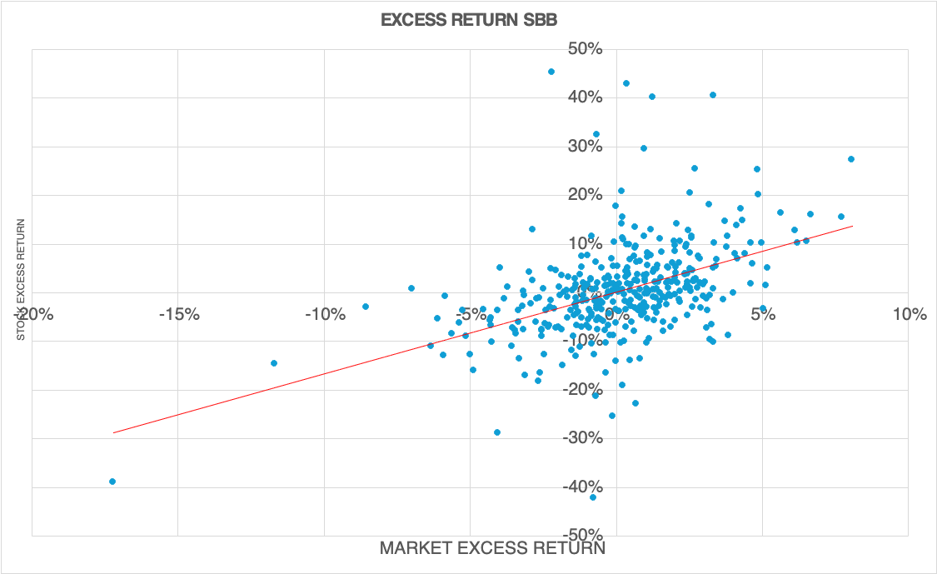

- Defensive beta < 1
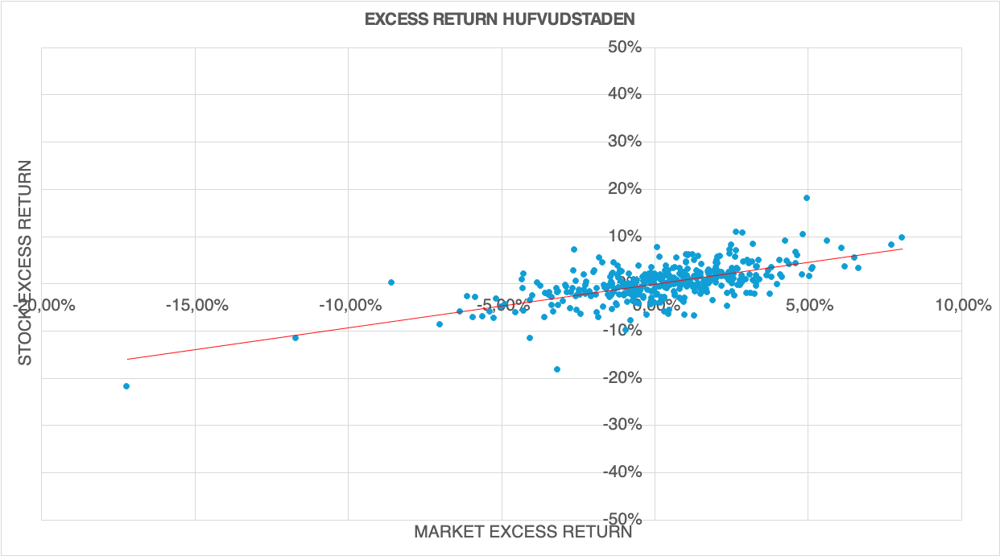

- Beta ≈ 1, higher R squared
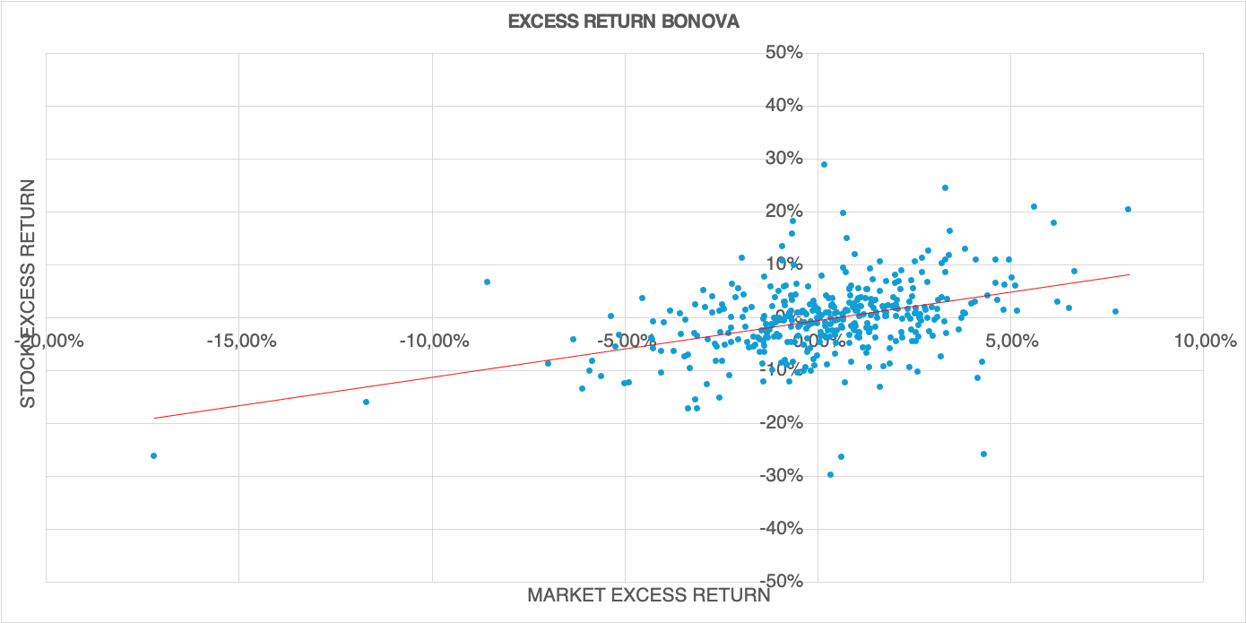

Interpretation
- Alpha: All alphas are statistically significant, consistent with CAPM (no abnormal returns)
- Beta:
  - AstraZeneca and Axfood: defensive, low beta (<1)
  - Bonava: cyclical, beta is approximately 1
  - SBB: beta = 1,68, the highest in the sample, strong significant (t=10,3), highly sensitive to market changes.
  - R squared: ranges from 0,05 – 0,40 with Hufvudstaden and SBB having the highest market explanation (systematic share)
  - Portfolio: beta = 0,86 < 1, showing reduced volatility through diversification.

Systematic vs. Unsystematic risk
Systematic vs. Unsystematic risk | Stock | Systematic (%) | Unsystematic (%)
 | AstraZeneca | 6,46% | 93,54%
 | Axfood | 5,72% | 94,28%
 | Bonova | 16,86% | 83,14%
 | Hufvudstaden | 39,94% | 60,06%
 | SBB | 21,83% | 78,17%

  - Differences in risk, AstraZeneca and Hufvudstaden
AstraZeneca and Hufvudstaden have differences between their systematic and unsystematic risk. AstraZeneca has high unsystematic risk (93.54%) meaning that almost all movements in that stock cannot be explain by movements in the market. Only 6.46% can be contributed to the market risk. An explanation of this is their global presence and relatively small exposure to the Swedish market. Most of their revenue comes from other parts of the world meaning that risk on the Swedish market does not affect AstraZeneca stock price in a significant way. Additionally he pharmaceutical business is not as effected by macro economic factors as a real estate company like Hufvudstaden. Hufvudstaden has higher systematic risk which could be explained by higher Swedish exposer and macroeconomic sensitive business in the form of real estate.

Results Fama-French 3-Factor Model

4.1 Regression output
Stock | Alpha (α) | t(α) | β(Mkt–RF) | t(β(Mkt-RF)) | β(SMB)
Apple | 0,00831 | 1,663759 | 1,170469133 | 10,11349208 | -0,207462439
CocaCola | -0,0007 | -0,20543 | 0,606725404 | 8,21720303 | -0,746208804
Microsoft | 0,0082 | 2,318953 | 1,047169327 | 12,79078666 | -0,63133271

 | t(β(SMB)) | β(HML) | t(β(HML)) | R²
Apple | -1,132109691 | -0,459234706 | -3,449717744 | 0,469571776
CocaCola | -6,38263577 | 0,300548869 | 3,538788628 | 0,406815852
Microsoft | -4,870196548 | -0,441339449 | -4,686631191 | 0,584755431

Interpretation:
- Market factor t(β(Mkt-RF)) positive and highly significant for all stocks.
- SMB negative: all are large-cap stocks.
- HML: positive for CocaCola (value); negative for apple and Microsoft (growth).
- Only Microsoft shows a statistically significant positive alpha (t=2,3), suggesting mild overperformance
- R squared values (0.41-0.59) indicate strong model fit.

CAPM (Single factor) Comparison regression
Stock | Alpha (α) | t(α) | β(Mkt–RF) | t(β) | R²
Apple | 0,009739216 | 1,890510391 | 1,127741481 | 9,854911373 | 0,414828198
CocaCola | 0,002004774 | 0,547542754 | 0,45784326 | 5,629340491 | 0,187856856
Microsoft | 0,01132616 | 2,789736209 | 0,919495978 | 10,19573053 | 0,431424199

Observations:
- R squared increases substantially under FF3.
- CAPM beta slightly lower because SMB/HML effects are omitted.
- Microsoft’s alpha remains significant in both models, robust excess performance.

Interpretation summary
- Alpha (abnormal return): Only Microsoft’s alpha is statistically significant, outperformed model predication.
- SMB: Negative across all, large-cap stocks.
- HML: Value exposure positive for Coca-Cola, negative for Apple and Microsoft.
- R²: Higher for FF3 than CAPM, three-factor model captures more systematic variation.
- Overall: Fama-French provides a superior fit and eliminates most abnormal returns observed in CAPM.

Comparison CAPM vs. Fama-French

Interpretation between aspects
Factors: The FF3 model includes additional systematic drivers which includes Market, Small Minus Big (size factor) and High minus Low (high book to market), compared to the CAPM model which only includes the Market factor.
R² range: Given by the results, FF3 improves explanatory power since SMB and HML capture systematic risks that CAPM misses, the variation in stock returns is explained by increasing R².
Alpha: From the output, FF3 reduces alpha even more than the CAPM model since SMB and HML factors capture return components that CAPM leaves unexplained, leaving fewer abnormal returns.
Beta: FF3 uses three Betas which spreads the exposure to systematic risks over three factors, while the CAPM model use one Beta to show the exposure to systematic risk.

Conclusion
- CAPM Findings
  - Betas align with industry risk expectations.
  - SBB is most market-sensitive; AstraZeneca/Axfood most defensive.
  - The diversified portfolio exhibits lower systematic risk
  - No significant abnormal returns; CAPM consistent with market efficiency.
Results from the CAPM model show that the beta values mostly align with the stocks respective industry risk expectation. Stocks in medication, healthcare, food and beverage markets tend to have a low beta value because of its necessity and non-cyclical demand. SBB has a higher beta value which is higher than the average for its market. This can be explained by high levels of debt (leverage).
The diversified portfolio smoothes out the Beta and gives a lower exposure to systematic risk than some of the higher beta stocks. None of the assets in the portfolio show abnormalities in return. All alpha values are between -0,0057 and 0,0021 which is close to zero. This indicates that CAPM is consistent with market efficiency.
- Fama-French Findings
  - The 3-factor model fits better than CAPM (higher R squared).
  - SMB and HML are economically and statistically significant.
  - Only Microsoft shows a small, significant alpha.
  - Overall, the FF3 model explains cross-sectional return differences more effectively.
Results from the Fama-French model shows that more adding the two variables, SMB and HML, increases R squared meaning that the model fits better then CAPM. Fama-French also reduces noise in the alpha output making it more accurate. HML tells us that Apple and Microsoft are growth stock, investors a expecting a bright future for the company, stock value is partly based on future expectations. Coca Cola has a positive HML, which suggest that it is a value stock. SMB for all US companies are negative, which means that all companies are large and stable on the market.

